**2019 Community Concert Series**

**Upcoming 2019 Community Concert Series**

**March 8th** -Friday night, March 8th - **I AM KING**

**"The Ultimate Tribute to Michael Jackson"**Tickets are **$25**

Click here to purchse tickets for [**I AM King**](https://www.itickets.com/events/415582.html)

Featuring Michael Jackson tribute artists who can sing LIVE while mastering the intense dancing that Jackson was so famous for, I AM KING  takes the audience on a musical and visual journey into the world of the KING OF POP.

The creators of I AM KING have put together an incredible cast of talented musicians and Broadway and Las Vegas dancers to bring Jackson to life in an explosion of unmatched energetic perfection.

I AM KING features amazing renditions of Jackson’s biggest hits including “Bad”,”Billie Jean”, “Thriller”, “Man in the Mirror”, “Human Nature” and many more.

[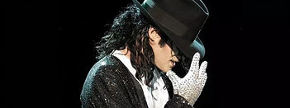](https://www.itickets.com/events/415582.html)

**June 1st** - **Madd Hoss Jackson.**..Tickets are **$25**

[**Click Here**](https://www.itickets.com/events/415586.html) to purchase Madd Hoss Jackson tickets.

Madd Hoss Jackson is a band as unique as its name. Like a breath of fresh air, Madd Hoss Jackson is a group that will bring you an energetic live show with music that is diverse as any act you have ever seen, and they’ll do it naturally and keep any crowd entertained from their very first song to the very last.

Madd Hoss Jackson’s fan base has been growing at an impressive rate all over Illinois, Missouri, Iowa, and Wisconsin thanks to an amazing array of shows and venues.  Madd Hoss Jackson is able to please such a wide array of tastes and ages because of their incredibly varied song list.  Madd Hoss Jackson will do it all and knows just when to pull out the style needed to keep any crowd entertained.

[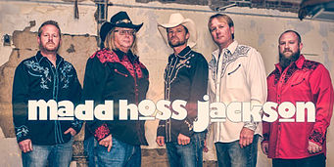](https://www.itickets.com/events/415586.html)

**August 10th** - **Simply Elton, Simply Billy.**. Two shows in one a tribute to the music of Elton John and Billy Joel featuring Brian Harris..

Tickets are **$25**

[**Click here to buy online tickets for the Simply Elton, Simply Billy**](https://www.itickets.com/events/415591.html)

Simply Elton is the over-the-top spectacle of a tribute to the one and only Sir Elton John.  Brian Harris brings a never-ending supply of energy, piano virtuosity, spot-on Elton-styled vocals, amazing costuming and crazy stage antics to give audiences EVERYTHING they expect from an Elton John show (and more!)

SIMPLY BILLY is the brand new tribute show that brings the incredible songwriting, vocals and pianistic virtuosity of Billy Joel to the stage for audiences to revel in!  Brian Harris weaves together meticulously styled Billy Joel vocals,  concert pianist "chops" and endless energy in presenting a show that will dazzle audiences. The Simply Billy performance is part of a dual show with Simply Elton,  putting into a single show the magic of two of the greatest "piano guys" the world has ever seen!

[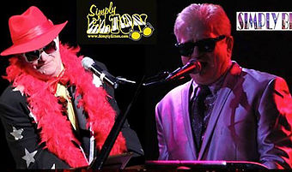](https://www.itickets.com/events/396693.html)

**November 30th** - **The John Berry Christmas**

Tickets are **$25**

[**Click here to buy online tickets for The John Berry Christmas**](https://www.itickets.com/events/415592.html)

John Berry rose to stardom on the country charts in the 1990s with such mega hits as Your Love Amazes Me, Standing on the Edge of Goodbye and She’s Taken a Shine. His annual Christmas tours brighten the holidays for thousands, as does his electrifying rendition of O’ Holy Night.

During his star-making decade, John placed 20 singles on the county charts, 6 of which went Top 5, with Your Love Amazes Me, scoring a #1 on the Billboard and Radio & Records Country Chart as well as Standing on the Edge of Goodbye and She’s Taken a Shine earning the #1 slot in Radio & Records . He has earned multiple Gold and Platinum records over the years.  But it was his stunning performance of the title track of the 1995 CD O’ Holy Night that led to his most enduring legacy to date. John began doing special Christmas tours that year and 2016 marked his 20th anniversary holiday concert tour. He appeared two years in the series and will be back by popular demand with his amazing Christmas show in the Washington High School Auditorium Saturday night, November 30th.

[](https://www.itickets.com/events/415592.html)

All concerts will be held at:

**Washington High School Auditorium**

**608 E. Walnut St., Washington, IN.**

All shows begin at **7:30pm**, with doors opening at **6:30pm.**

**Buy the season pass for all four shows for only $75!**

**Season passes ($75 ea.) and individual tickets ($25 ea.)** **are available Monday – Friday; 8am – 4pm at** **the:**

**Washington Times Herald**

**102 E. Van Trees St., Washington, IN**

**and**

**Daviess County Chamber of Commerce**

**1 Train Depot St., Washington, IN**

**Cash or check is the only method of payment at the Chamber of Commerce Office**

**For Questions you may call 812-254-5262**