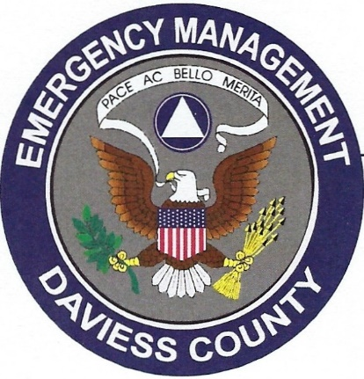

**DAVIESS COUNTY EMERGENCY MANAGEMENT AGENCY**

Daviess County Security Center • 101 NE 4th St. Washington, IN 47501

***Scott Myers, Director***

812-254-5975

daviesscountyema@gmail.com

**FOR IMMEDIATE RELEASE**

August 24, 2022

[Washington, Indiana] – The City of Washington and Daviess County Emergency Management Agency has been working with the Southern Baptist Disaster Relief group to help with the flooding damage that occurred during July 23-25, 2022. On Monday, August 29, 2022, representatives from the Southern Baptist Relief group will be contacting homeowners that reported to the 211 system to do assessments of the damage. The 211 system is now closed for any additional reporting.